## INTERNSHIP REPORT

*This Internship report is submitted to*

**St. Vincent Pallotti College of Engineering & Technology** (An Autonomous Institution Affiliated to Rashtrasant Tukadoji Maharaj Nagpur University, Nagpur)

***In partial fulfillment of the requirements for the award of the degree of Bachelor of Technology in***

### ARTIFICIAL INTELLIGENCE

***Submitted by***

### TRUPTI NIRGULKAR

**Under the supervision of**

### PROF. POOJA WAGH

Assistant Professor

##### in

Clustor Computing, Nagpur &

Cognizant Technology Solutions, Chennai

### Academic Year 2024-25



**Department of Artificial Intelligence**

# ST. VINCENT PALLOTTI

##### COLLEGE OF ENGINEERING AND TECHNOLOGY

Gavsi Manapur, Wardha Road, Nagpur -441108

## CERTIFICATE

This is to certify that the “**Internship report”** submitted by **TRUPTI NIRGULKAR (21007019)** is work done by her and submitted during 2024-2025 academic year, in partial fulfilment of the requirements for the award of the degree of **BACHELOR OF TECHNOLOGY in Artificial Intelligence,** at **St. Vincent Pallotti College of Engineering & Technology, Nagpur.**

**Prof. Pooja Wagh Prof. Sachin Patil**

**Assistant Professor Assistant Professor**

##### Department Mentor Internship Coordinator

**Dr. Vikas Bhowate Dr. Vijay Wadhai**

**Associate Professor Principal**

**Head of the Department**



**Department of Artificial Intelligence**

# ST. VINCENT PALLOTTI

**COLLEGE OF ENGINEERING AND TECHNOLOGY**

Gavsi Manapur, Wardha Road, Nagpur – 441108

(An Autonomous Institute affiliated to RTMNU, Nagpur)

## ORGANIZATION CERTIFICATE

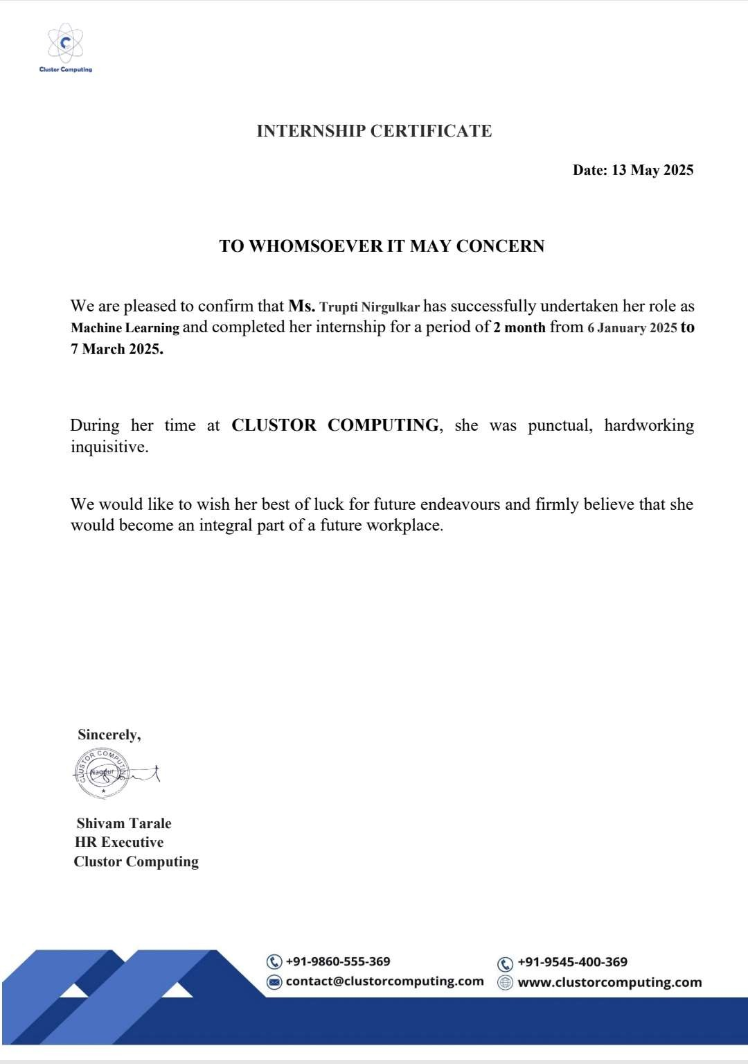

**ACKNOWLEDGEMENT**

This Internship work is one of the major milestones in my journey of learning. I would like to sincerely thank **Shivam Tarale, HR, Clustor Computing** and **Sivakumar Nivarthi, Senior Manager, Cognizant Technology Solution** for her/his guidance at every stage of the internship and for her/his prompt and insightful input.

I would like to thank **Dr. Vikas Bhowate, Head, Department of Artificial Intelligence** and all our faculty members who reviewed my work and pointed out the shortcomings, their valuable insights and recommendations propelled my internship work forward, helping me overcome challenges and complexities along the way.

I am especially thankful to our **departmental mentor, Prof. Pooja Wagh**, for his/her dedicated mentorship and consistent support throughout the course of the internship. His/her guidance was instrumental in shaping my approach and ensuring meaningful progress.

Also, I am very grateful to the Institute **Principal Dr. Vijay M. Wadhai and Management,** for their support facilities provided during the internship.

**Trupti Nirgulkar**

### ABSTRACT

The internship was conducted in two phases at Clustor Computing and Cognizant Technology Solutions, providing valuable exposure to both development-focused and enterprise-level IT environments.

At Clustor Computing, I worked as a Machine Learning intern where I gained hands-on experience in data preprocessing, visualization, and documentation of Agile practices. I was involved in real-time applications of computer vision and model deployment, along with system integration using external hardware. These tasks enhanced my understanding of applied AI and end-to-end software development workflows.

The second phase at Cognizant Technology Solutions I underwent structured training in the SAP Sales and Distribution (SAP SD) domain. This phase introduced me to enterprise- level software systems and gave me hands-on exposure to how key business processes such as sales, billing, and customer relationship management are handled within the SAP ecosystem.

Overall, the experience helped me bridge the gap between classroom learning and real- world application, boosting my confidence and better preparing me to take on future challenges in the tech industry.

**TABLE OF CONTENTS**

|  |  |  |
| --- | --- | --- |
| **CHAPTER NO.** | **TITLE** | **PAGE**  **NO.** |
|  | **LIST OF FIGURES** | **I** |
| **1** | **INTRODUCTION** | **1** |
| **2** | **COMPANY/ORGANIZATION**   * 1. Clustor Computing   2. Cognizant Technology Solutions | **2**  2  3 |
| **3** | **INTERNSHIP OBJECTIVES** | **4** |
| **4** | **TECHNOLOGIES USED**   * 1. Technologies Used at Clustor Computing      1. Programming Languages      2. Frameworks and Libraries      3. Tools   2. Technologies Used at Cognizant      1. SAP Software | **6**  6  6  6  7  7  7 |
| **5** | **MODULES DEVELOPED / TASKS PERFORMED**   * 1. Vehicle Data Analysis and Visualization   2. Vehicle Number Plate Detection System   3. End-to-End Implementation of SAP SD for Order Processing and Billing | **8**  **8**  **9** |
| **6** | **WEEKLY OVERVIEW OF INTERNSHIP**  **ACTIVITIES** | **11** |
| **7** | **LEARNING OUTCOMES** | **15** |
| **8** | **CHALLENGES FACED AND SOLUTIONS** | **16** |
| **9** | **CONCLUSION** | **17** |
|  | **BIBLIOGRAPHY / REFERENCES** | **18** |
|  | **ANNEXURES** | **19** |

### LIST OF FIGURES

|  |  |  |
| --- | --- | --- |
| **FIGURE NO** | **FIGURE NAME** | **PAGE NO** |
| 1 | Vehicle Data Analysis | 19 |
| 2 | Number plate detection | 19 |
| 3 | Customer Data Creation | 20 |
| 4 | Material Data Creation | 20 |
| 5 | Sales Order Processing | 21 |
| 6 | Pricing Condition Setup | 21 |

**I**

## CHAPTER 1 INTRODUCTION

### CHAPTER 1 INTRODUCTION

As part of my academic journey, I interned at Clustor Computing and Cognizant Technology Solutions, gaining hands-on experience in both AI-based applications and enterprise IT systems.

For the initial phase, I worked at Clustor Computing, where I engaged in practical machine learning projects. One of my key projects was vehicle data analysis, where I applied data processing techniques and predictive modeling to extract meaningful insights from large datasets. Another significant project was vehicle number plate detection, where I implemented computer vision techniques to automate license plate recognition for security and monitoring applications. These tasks helped me strengthen my understanding of data analysis, model training, and problem-solving in real-world scenarios.

In the following phase, I joined **Cognizant Technology Solutions**, where I received comprehensive training in the SAP Sales and Distribution (SD) domain. SAP SD is a key module in the SAP ERP system that handles all processes related to order processing, shipping, billing, and customer relationship management. During the training, I learned how to configure and manage components such as customer master data, material master data, pricing conditions, sales documents, and delivery processes. I also explored the integration of SD with other modules like MM (Materials Management) and FI (Financial Accounting), which deepened my understanding of how cross-functional business operations are managed within an ERP system. Through hands-on exercises, real-time case studies, and simulation- based learning, I gained valuable insights into how businesses use SAP to streamline their sales cycle, improve accuracy, and enhance customer service.

This internship experience allowed me to sharpen my technical skills in both AI and enterprise IT infrastructure, providing a comprehensive view of real-world applications and system-level problem-solving.

1

## CHAPTER 2 COMPANY/ORGANIZATION PROFILE

### CHAPTER 2

**COMPANY/ ORGANIZATION PROFILE**

* 1. **Clustor Computing**

Clustor Computing is an IT startup located in Nagpur, specializing in digital transformation and intelligent automation solutions. The company leverages advanced methods in business intelligence and artificial intelligence to modernize industries and automate systems. Clustor offers next-generation services, including cloud computing, big data, IoT, mobile internet, and AI-driven tools for marketing, design, communication, and business modeling.

With a team size of around 11–50 professionals, Clustor serves clients from various domains such as fintech, healthcare, software, and more. The company creates scalable solutions that help businesses become more connected, data-driven, and efficient. Their focus on research and development enables them to provide customized and innovative solutions tailored to clients' needs. The company’s strong commitment to emerging technologies like machine learning, deep learning, and natural language processing (NLP) further solidifies their position in the tech landscape.

Clustor Computing is known for its agility and responsiveness, adapting quickly to market trends and customer requirements. They place a high emphasis on fostering a collaborative work environment, where teams work closely on solving complex problems. The company maintains strong client relationships by providing continuous support and ensuring the scalability and sustainability of the solutions offered.

Clustor Computing is also focused on sustainability, exploring eco-friendly technologies and practices that reduce environmental impact while improving efficiency. Their overarching goal is to help businesses embrace digital transformation, making them more efficient, sustainable, and data-driven.

2

* 1. **Cognizant Technology Solution**

Cognizant is a multinational IT services and consulting company headquartered in Teaneck, New Jersey, USA. Established in 1994 as a technology division of Dun & Bradstreet, it became an independent company in 1996. Cognizant is a leading provider of digital, technology, consulting, and operations services, and has grown to become one of the largest IT services companies in the world.

Cognizant specializes in delivering end-to-end services across various industries, including financial services, healthcare, manufacturing, retail, and communications. Their expertise spans across digital transformation, cloud computing, artificial intelligence (AI), data analytics, enterprise solutions, and IT infrastructure management. The company provides solutions in software development, system integration, IT consulting, and business process outsourcing (BPO).

Cognizant’s clients range from Fortune 500 companies to startups, and they are known for building long-term relationships with clients by delivering high-quality, scalable solutions. The company has a strong global presence, with operations across North America, Europe, Asia, and Latin America.

The company is also recognized for its focus on employee development and training, creating a work culture that encourages innovation, diversity, and continuous learning. Cognizant's commitment to innovation is reflected in its continuous investment in emerging technologies such as blockchain, IoT, and cybersecurity.

3

## CHAPTER 3 INTERNSHIP OBJECTIVES

### CHAPTER 3 INTERNSHIP OBJECTIVES

* **Apply Academic Knowledge in Real-World Scenarios:** To translate classroom learning in machine learning, artificial intelligence, and enterprise systems into practical skills by working on industry-relevant projects and use cases.
* **Real-world Application of AI and Machine Learning:** At Clustor Computing, the primary objective was to gain hands-on experience in applying AI and machine learning algorithms to solve real-world problems. This included working on projects such as vehicle data analysis and vehicle number plate detection which involved using tools like Python, OpenCV, and YOLO. These tasks helped me understand the end-to- end process of developing AI-based solutions.
* **Exposure to System Integration:** Another key objective at Clustor Computing was to understand the integration of AI models with hardware systems, such as cameras and sensors. This gave me a comprehensive understanding of how AI systems interact with external devices for real-time applications.
* **Receive In-Depth ERP Training in SAP SD**: To understand the SAP Sales and Distribution module in detail, including sales order processing, pricing, billing, customer data management, and delivery processes.
* **Understand End-to-End Business Process Management:** To gain insight into how business workflows from sales to invoice generation are managed and automated within an ERP system like SAP.
* **Explore SAP SD Integration with Other Modules:** To study the interaction of SD with other modules like MM (Materials Management) and FI (Financial Accounting), gaining a complete view of organizational data flow and system-wide coherence.
* **Build Technical Proficiency in Industry Tools:** To get hands-on experience with tools and platforms such as HTML, CSS, JavaScript, Python, and SAP GUI, enhancing both development and enterprise software skills.

4

* **Improve Communication and Team Collaboration Skills:** To work collaboratively with mentors and peers, participate in discussions, and present project outcomes effectively, contributing to team-based problem-solving.
* **Gain Exposure to Corporate Work Culture:** To experience a professional work environment, understand expectations, workflows, and ethics in a corporate setting, and adapt to the standards of the IT industry.
* **Strengthen Adaptability and Learning Mindset:** To become comfortable working in different domains (development and enterprise systems), and quickly learn new tools, concepts, and practices required for each.

5

## CHAPTER 4 TECHNOLOGIES USED

### CHAPTER 4 TECHNOLOGIES USED

##### Technologies Used at Clustor Computing

* + 1. **Programming Languages**
       - **Python:** Python was the main programming language used during the internship for tasks like machine learning model development, image processing, and backend integration. Python’s libraries and flexibility enabled fast and efficient development for AI solutions such as Vehicle number plate detection.

##### Frameworks and Libraries

* + - * **OpenCV:** A key library for computer vision, OpenCV was used extensively for reading and manipulating video frames, object detection, and feature extraction.
      * **Pandas:** Used for data manipulation and cleaning, Pandas played a major role in managing large datasets and generating reports for AI-driven projects.
      * **NumPy:** NumPy was used for numerical operations and handling multidimensional arrays, especially when working with large datasets during machine learning model training.
      * **Matplotlib:** Used for visualizing data and model performance metrics, Matplotlib helped generate graphs and charts to track accuracy, loss, and other key performance indicators.

##### Tools

* + - * **Jupyter Notebook:** Jupyter was used for prototyping, data exploration, and testing machine learning models in an interactive environment.
      * **Google Colab:** Provided cloud-based execution with free GPU access for model training and development.

6

##### Technologies used at Cognizant Technology Solution:

* + 1. **SAP Software**
       - **SAP GUI** – The primary interface for interacting with SAP ERP modules like SD, MM, and FI. It enables users to navigate different business processes, manage data, and execute system functions efficiently.
       - **SAP SD Module** – Focuses on sales order processing, customer management, and billing within SAP ERP. It integrates with Material Management (MM) for stock availability checks and Financial Accounting (FI) for revenue tracking, ensuring smooth order-to-cash operations.
       - **MS Excel** – Used for maintaining and analyzing master data, order tracking, and process simulations in SAP training.

7

## CHAPTER 5 MODULES DEVELOPED / TASKS

**PERFORMED**

### CHAPTER 5

**MODULES DEVELOPED / TASKS PERFORMED**

During the course of my internship, I worked on a variety of hands-on projects and training modules that helped me strengthen my technical skills and apply theoretical knowledge to realworld problems. At Clustor Computing, I was involved in developing AI-based solutions and data visualization tasks, while at Cognizant, I underwent corporate-level training focused on SAP SD. Below are the detailed descriptions of the projects and tasks I worked on during my internship at both organizations.

##### Vehicle Data Analysis and Visualization

My first project involved selecting a dataset and performing data preprocessing, cleaning, and visualization. I chose a vehicle dataset, which contained attributes like fuel efficiency, speed patterns, and engine performance. Using Python libraries like Pandas and NumPy,

I handled missing values, encoded categorical data, and normalized the dataset for better analysis. I then utilized Matplotlib and Seaborn to visualize key insights, such as vehicle performance trends, fuel consumption variations, and patterns that could inform transportation optimization strategies.

##### : Vehicle Number Plate Detection System

The Vehicle Number Plate Detection System is an AI-based solution designed to recognize and extract license plate information from images using Python, OpenCV, and EasyOCR. The system operates through a structured pipeline that begins with image preprocessing, where techniques such as grayscale conversion, noise reduction, and edge detection refine the input image to improve clarity. OpenCV is utilized to identify contours and bounding boxes, which help isolate the plate from the rest of the image.

Once the plate is detected, the EasyOCR library is used to extract the alphanumeric characters from the license plate with high accuracy. This Optical Character Recognition (OCR) technique converts the extracted text into a readable format, which can then be stored or processed for further applications. The system ensures reliable recognition in varying lighting conditions and angles, making it suitable for real-world scenarios.

This AI-driven solution supports automated toll collection, traffic monitoring, and security enforcement by enabling efficient vehicle identification.

8

##### End-to-End Implementation of SAP SD for Order Processing and Billing

During the second phase of my internship at Cognizant Technology Solutions, I underwent in-depth, hands-on training in the SAP Sales and Distribution (SD) module. This phase introduced me to real-time enterprise operations and helped me understand the role of ERP systems in streamlining complex business workflows. Through this experience, I gained comprehensive insight into how large organizations manage customer relationships, sales cycles, and logistics using SAP.Over the course of the training, I worked with several critical components of the SD module, including:

##### Customer Master Creation:

I learned to create and maintain customer master records, which include general data (e.g., name, address), company code data (e.g., payment terms), and sales area data (e.g., shipping conditions, pricing group). Understanding how to structure this data is essential for executing accurate and efficient sales transactions.

##### Material Master Creation:

I worked on defining material master data that includes essential information like material type, units of measure, pricing details, and stock availability. These records are shared across various departments such as Sales, Inventory, and Procurement, ensuring consistency and integration within the system.

##### Pricing Procedure Configuration:

I gained exposure to the condition technique, which is the backbone of SAP pricing. This involved configuring condition tables, access sequences, condition types, and pricing procedures. I practiced setting up custom pricing rules to reflect real-world scenarios like discounts, surcharges, and freight costs.

##### Order-to-Cash (O2C) Process:

I followed the complete O2C lifecycle, starting from inquiry and quotation to sales order creation, delivery processing, billing, and payment receipt. This process illustrated how different SAP modules like SD, MM, and FI work together to support an end-to-end business transaction.

9

##### Contracts and Consignment Process:

I explored long-term sales agreements such as quantity and value contracts, which allow predefined sales terms over a certain period. In consignment processes, I learned how goods are stored at the customer's site but remain the seller’s property until consumed, making inventory and billing more flexible and efficient.

##### Free Goods Management:

I configured scenarios for both inclusive and exclusive free goods determination. These involved setting rules where additional products are delivered for free based on quantity thresholds, customer groups, or promotional campaigns, helping to simulate real-world marketing strategies.

##### Third-Party Order Processing:

This involved creating sales orders that automatically trigger a purchase requisition to an external vendor. I studied how the goods are shipped directly from the vendor to the customer, and how the billing process is managed through inter-company transactions. It demonstrated how SAP facilitates seamless coordination between the sales team, procurement department, and external suppliers.

10

## CHAPTER 6

**WEEKLY OVERVIEW OF INTERNSHIP ACTIVITIES**

### CHAPTER 6

**WEEKLY OVERVIEW OF INTERNSHIP ACTIVITIES**

This chapter presents a detailed weekly account of tasks completed, technologies explored, and skills acquired throughout the 18-week internship. It highlights the learning curve from training to full-fledged project development.

##### Week 1:

In the first week, I selected a vehicle dataset containing attributes like fuel efficiency, speed, engine performance, and environmental impact. The data was cleaned to remove missing values, outliers, and inconsistencies, ensuring accuracy. Preprocessing techniques such as normalization and feature scaling were applied to optimize the dataset for analysis, enabling valuable insights into vehicle performance trends.

##### Week 2:

In the second week, I focused on data visualization and documentation, using Matplotlib and Seaborn to create interactive plots that revealed patterns in fuel consumption, speed variations, and vehicle efficiency. Key visualizations, including heatmaps, bar charts, and scatter plots, helped analyze correlations between attributes. A detailed report documented data collection, visualization techniques, and key insights from the analysis.

##### Week 3:

In the third week, I explored predictive modeling using Linear Regression, Decision Trees, and Random Forests to analyze fuel efficiency and vehicle performance. I applied cross- validation and error metrics to evaluate model accuracy and documented insights on how vehicle attributes affect fuel consumption and operational efficiency.

##### Week 4:

In the fourth week, the focus was on reporting, deployment, and future improvements. I compiled insights from visualization and predictive modeling into a structured report, outlining patterns and recommendations for optimizing vehicle operations.

11

##### Week 5:

This week marked the beginning of an industrial project focused on vehicle number plate detection using Python, OpenCV, and EasyOCR. Marked the start of the project, focusing on setting up the environment and installing required libraries.

##### Week 6:

In week 6 data collection and preprocessing was done. Images were cleaned using grayscale conversion, noise removal, and contrast enhancement to improve detection accuracy. Bounding box and edge detection were applied to localize the number plate effectively.

##### Week 7:

OCR Processing & Text Extraction EasyOCR was used for extracting alphanumeric characters from detected plates. Post-processing techniques like text formatting and filtering were implemented to refine recognition accuracy.

##### Week 8:

The system’s accuracy was tested on different images. Preprocessing thresholds were fine- tuned, and OCR settings were optimized to improve performance. Comparisons with Tesseract OCR were conducted.

##### Week 9:

The system was deployed using Flask, enabling real-time image uploads and plate recognition. Future improvements, such as deep learning-based plate detection, were outlined to enhance accuracy.

##### Week 10:

I completed the onboarding process at Cognizant, which began with the verification of essential documents such as academic records and identification proofs. We were then provided with official assets, including laptops and login credentials, to facilitate our word.A behavioral session was also conducted to introduce us to the company’s values, ethics, and professional expectations. During this period, I was also assigned my domain in SAP SD, which set the foundation for my training and future responsibilities.

12

##### Week 11:

In this week, training focused on the basics and introduction of SAP SD, including modules related to GST (SGST, CGST), sales organization, distribution channel, division, and plant. The trainer explained key concepts such as customer master data, payment terms, and account groups, along with hands-on practice on master data creation. As a result, I developed a clear understanding of SAP SD processes like sales organization and master data creation for around 500 customers and materials, which helped strengthen my foundational skills in SAP SD.

##### Week 12:

Focused on learning closure topics in SAP SD, especially the order-to-cash process. Gained understanding of the pricing procedure, condition types, access sequences, and practiced transactions like inquiry, quotation, sales order, delivery, and billing. Also performed hands-on tasks on credit/debit memos, scheduling agreements, and returns. Strengthened overall understanding and practical skills in SAP SD.

##### Week 13:

The training focused on sales documents in SAP SD, emphasizing types of contracts and return orders. Learned configuration of contracts, return order processes, and free goods scenarios through practical sessions. Additionally, behavioral training sessions covered emotional intelligence and public speaking, including a 1-minute talk to improve communication skills.

##### Week 14:

Focused on advanced SAP SD topics such as material determination, item listing, exclusion, availability check, third-party sales orders, and credit management. Underwent an interim evaluation with scenario-based questions and received a “green” rating with valuable feedback, enhancing understanding of SAP SD processes. Covered transport orders, intercompany sales, and special sales in SAP SD, followed by a final review of earlier topics. Engaged in team- based quiz activities and behavioral training sessions on storytelling and presentation skills in preparation for final evaluations.

13

##### Week 15:

Focused on learning stock transport orders (STO) and intercompany sales processes under special sales in SAP SD. Revised previous topics for final evaluation and participated in a Q&A quiz round among three teams. Behavioral training included storytelling, and participants prepared PowerPoint presentations for the final review. The key learning outcome was understanding and practicing special sales processes in SAP SD, particularly STO and intercompany sales.

##### Week 16:

Revised listing and exclusion material determination to enhance understanding of material selection. Participated in a behavioral training “In a Nutshell” exercise based on the stages of the moon landing, promoting teamwork. Engaged in a leadership connect session with the senior director, gaining insights into strategic decision-making.

##### Week 17:

Participated in BH training focused on role-based activities, where various team and organizational scenarios were provided to assess reactions and decision-making skills. Engaged in discussions to understand effective communication and problem-solving in workplace situations. Additionally, completed a mock interview, practicing structured responses and refining professional presentation skills.

##### Week 18:

Revised all SAP SD topics, ensuring a solid understanding of key concepts and processes. Successfully completed the final evaluation for SAP SD, demonstrating strong understanding and practical application of concepts. Received positive feedback, reflecting well on performance.

14

## CHAPTER 7 LEARNING OUTCOMES

### CHAPTER 7

#### LEARNING OUTCOMES

During my internship, I had the chance to work with Clustor Computing and Cognizant Technology Solutions, each offering distinct learning experiences.

**At Clustor Computing**, Through the Vehicle Data Analysis and Visualization project, I gained proficiency in data preprocessing techniques such as cleaning, normalization, and feature scaling, along with exploratory data analysis (EDA) using Matplotlib and Seaborn to visualize trends. In the Vehicle Number Plate Detection project, I strengthened my understanding of computer vision by applying OpenCV for object detection and EasyOCR for optical character recognition (OCR). Both projects enhanced my skills in automated vehicle identification, industry practices, problem-solving, and technical execution in data science and computer vision for security and traffic monitoring.

At **Cognizant Technology Solutions**, I was immersed in the world of enterprise resource planning (ERP) systems, specifically focusing on the SAP Sales and Distribution (SD) module. I learned how large-scale organizations use SAP to streamline their sales and distribution processes, from customer and material master creation to the complete Order- to-Cash (O2C) cycle. My training included configuring pricing procedures, managing contracts, handling consignment stock, and processing third-party orders. This exposure to real-time business processes deepened my understanding of how SAP integrates with other modules like Materials Management (MM) and Financial Accounting (FI) to create a unified business system. The experience not only broadened my technical knowledge but also sharpened my understanding of business workflows and the critical role of ERP systems in managing complex global operations.

15

## CHAPTER 8

**CHALLENGES FACED AND SOLUTIONS**

### CHAPTER 8 CHALLENGES FACED AND SOLUTION

Throughout my internship, I enhanced my technical and analytical skills by tackling challenges in data processing and computer vision. In the Vehicle Data Analysis and Visualization project, I addressed missing values and inconsistencies using Pandas, applying normalization and feature scaling for refined analysis. Matplotlib and Seaborn helped uncover trends through exploratory data analysis (EDA). In the Vehicle Number Plate Detection project, lighting and image quality issues affected plate localization. I improved detection using grayscale conversion, noise reduction, and edge detection in OpenCV. OCR misinterpretations were resolved by fine-tuning EasyOCR settings and applying text filtering techniques, ensuring precise text extraction.

At Cognizant Technology Solutions, one of the key challenges was understanding the complexity of SAP SD module and the interdependencies between various SAP processes. Learning to configure pricing procedures, handle third-party orders, and manage the Order-to-Cash (O2C) cycle was initially overwhelming due to the intricate business rules and technical configurations required. Additionally, navigating the SAP system and understanding the integration between the SD, MM, and FI modules took time and effort, especially in understanding the flow of data across these systems. It required a deep understanding of both technical aspects and business processes, which was a steep learning curve initial.

16

## CHAPTER 9 CONCLUSION

### CHAPTER 9 CONCLUSION

The internship experience at Clustor Computing and Cognizant has been highly valuable and enriching. At Clustor Computing, I had the opportunity to work on real-time projects related to data analysis, computer vision, and automation. These projects helped me enhance my technical skills, apply theoretical knowledge, and gain confidence in handling practical challenges. I learned to work independently as well as in a team, improving both my problem- solving and collaboration skills.

At Cognizant, I received hands-on training in the SAP Sales and Distribution (SD) module. I learned about key business processes including customer and material master creation, pricing configuration, and the Order-to-Cash cycle. This experience helped me understand the structure and importance of ERP systems in managing large-scale business operations, and how different modules within SAP integrate to support end-to-end functionality.

Overall, the internship deepened my technical knowledge and provided a platform to apply academic concepts in practical settings. It also improved my problem-solving abilities, adaptability, and professional communication—skills that will be valuable as I move forward in my career in the tech industry.

17

### BIBLIOGRAPHY / REFERENCES

#### REFERENCE PAPERS

1. A. N. D, S. M, and S. Y. G. Tilak, “Exploratory Data Analysis (EDA) and Data Visualization,” *Int.*

*J. Innov. Res. Electr. Electron. Instrum. Control Eng.* (IJIREFICE), vol. 12, no. 6, pp. –, Jun. 2024.

1. K. R. Kirubasankar, M. M. Kokila, M. I. Ishaaq, N. K. S, and S. T, “Object Detection for Vehicular Nameplate Detection Using EasyOCR and YOLOv3,” *Int. J. Innov. Res. Technol.* (IJIRT), vol. 11, no. 1, pp. –, Jan. 2024.
2. S. Apte, S. Chafekanade, A. Deore, A. Deshmukh, and I. Deshpande, “Automatic Car Number Plate Detection System Using OpenCV,” *Int. J. Res. Appl. Sci. Eng. Technol.* (IJRASET), vol. 11, no. 6, pp. –, Jun. 2023.
3. S. M. Gaikwad, N. R. Kumbhare, D. C. Chaudhari, and P. L. Gangurde, “Platesense: Intelligent License Plate Recognition With OpenCV,” *Int. J. Creat. Res. Thoughts* (IJCRT), vol. 11, no. 12, pp. –

, Dec. 2023. [Online]. Available:

1. SAP SD Book https://[www.researchgate.net/publication/320852943_SAP-SD](http://www.researchgate.net/publication/320852943_SAP-SD)

18

# ANNEXURES

### ANNEXURES

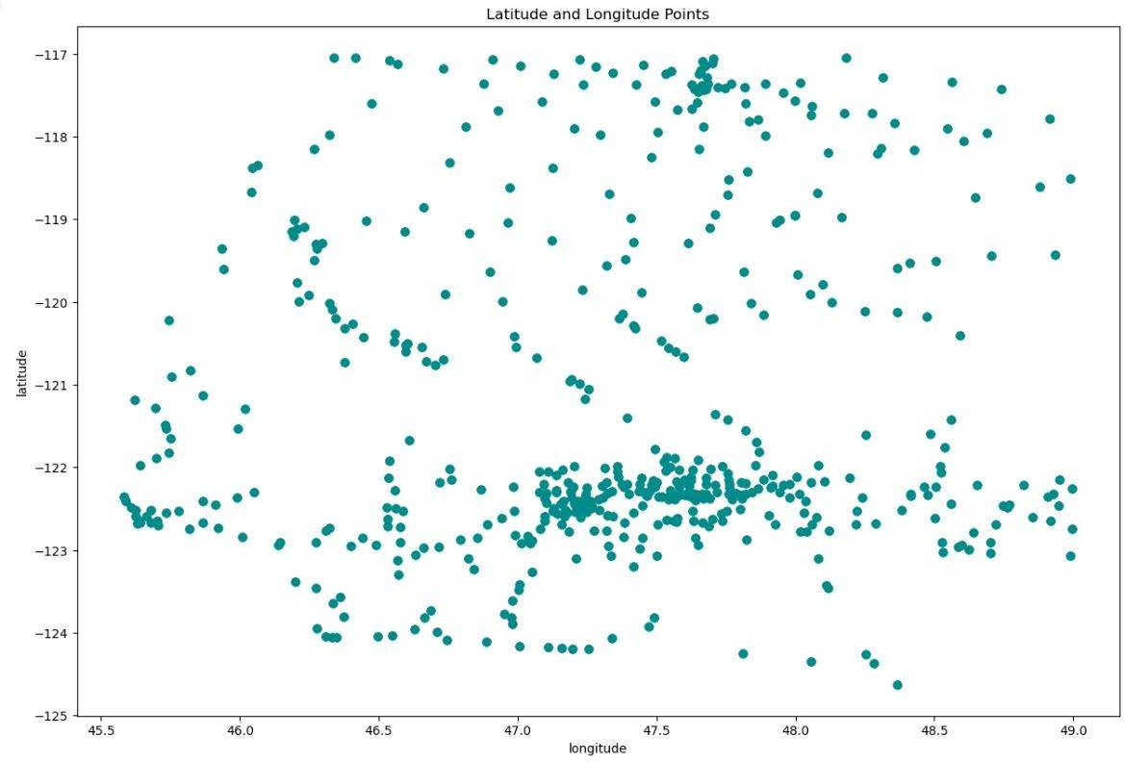

Fig 1. Vehicle data analysis

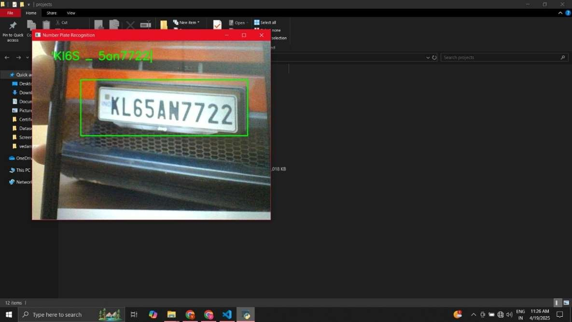

Fig 2. Number plate detection

19

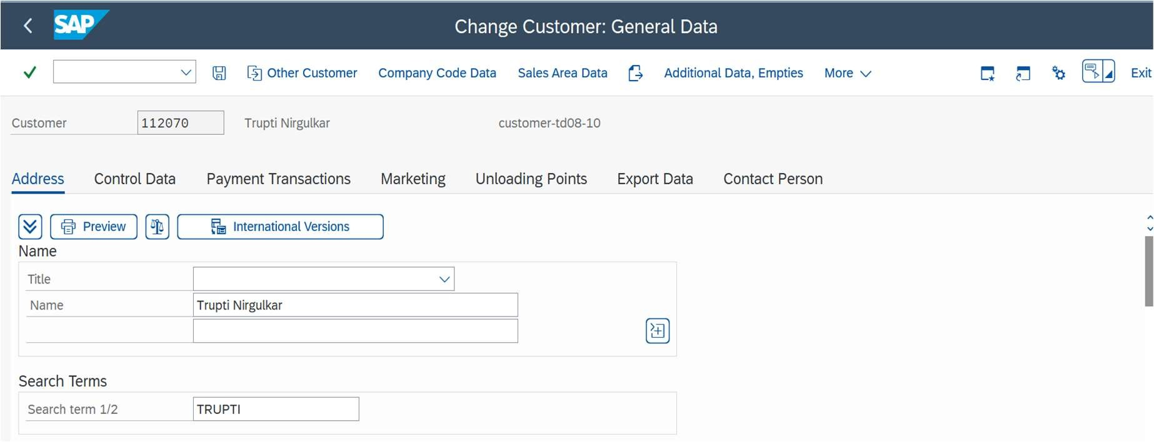

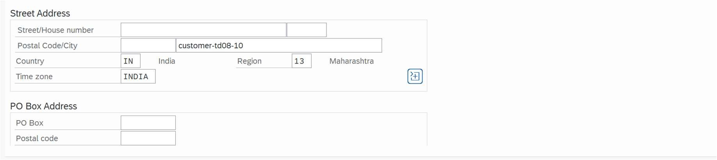

Fig 3. Customer Data Creation

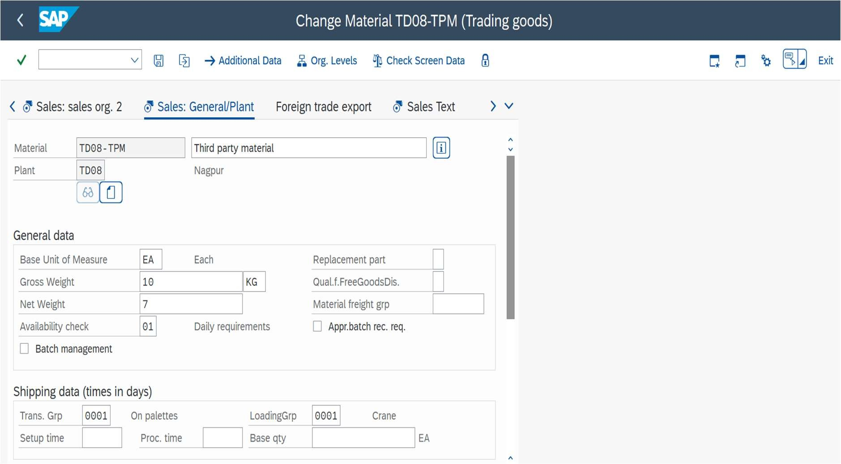

Fig 4. Material Data Creation Image



20

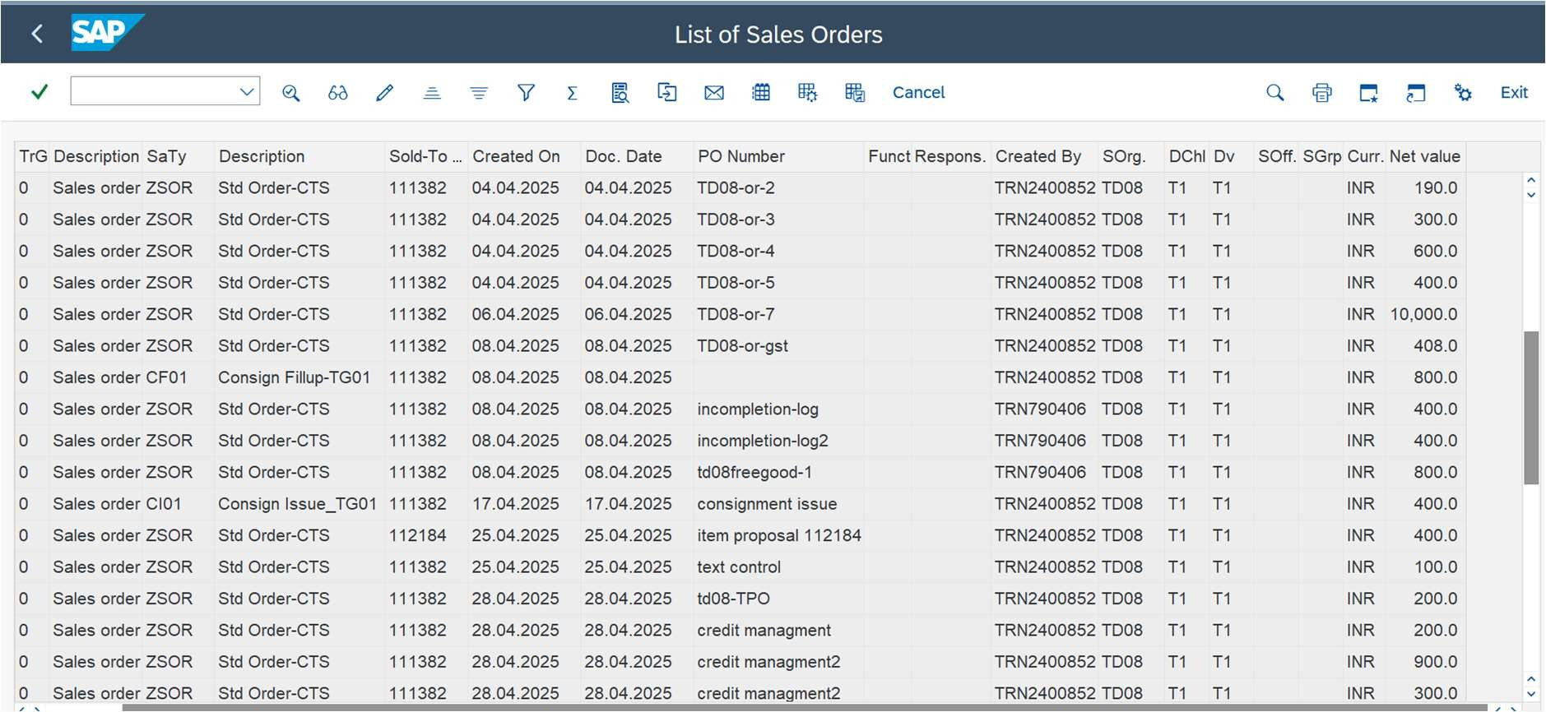

Fig 5. Sales Order Processing

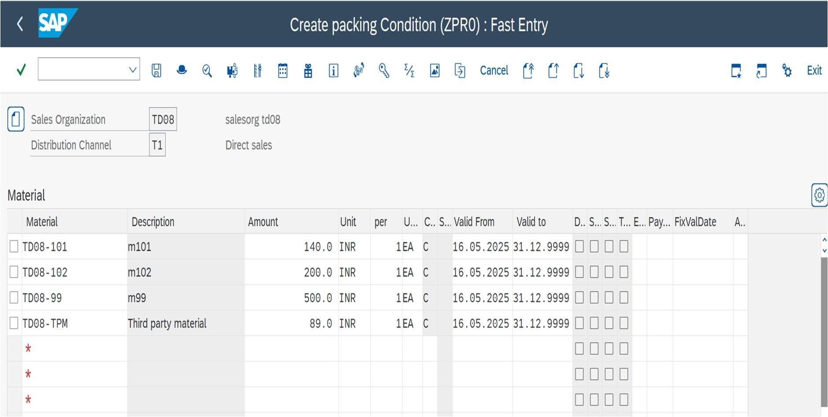

Fig 6. Pricing Condition Setup

21